|  |  |
| --- | --- |
|  | ***Department of Electronics and Telecommunication Engineering***  ***(NBA ACCREDIATED)***  ***Digital Communication Laboratory***  ***Academic Year 2020-2021***  ***Odd Semester*** |

|  |  |
| --- | --- |
| **Course Code** | ECC603 |
| **Subject Professor In-charge** | Prof. Santosh Jagtap |
| **Student Name** | Anuj Shah |
| **Roll Number** | 18104B0024 |
| **Class** | TE EXTC |
| **Division** | B |
| **Date of Performance** | 7th April 2021 |
| **Date of Submission** |  |

**EXPERIMENT NO.4**

**Design Half Dipole antenna and Plot far field radiation pattern and measure its performance parameters.**

|  |  |
| --- | --- |
| **Total**  **(10 Marks)** | **Sign** |
|  |  |

**EXPERIMENT No.4**

**Title:** Design Half dipole antenna and plot far field radiation pattern and measure its

performance parameters by using 4NEC simulation tool.

**Estimated time to complete this experiment:** 02 hours

**Objective:** Measurement of circuit, far field and network parameters of antenna

**CO to be achieved:** CO1, CO2.

**Expected Outcome of Experiment:** Design andPerformance analysis of half dipole antenna.

**Pre Lab/ Prior Concepts:** Radiation pattern, Impedance, SWR

**Theory (2 Marks)**

Field expression, Radiation resistance, Impedance

Radiation resistance:

Radiation resistance is that part of an antenna’s feedpoint electrical resistance that is caused by the radiation of electromagnetic waves from the antenna. In radio transmission, a radio transmitter is connected to an antenna. The transmitter generates a radio frequency alternating current which is applied to the antenna, and the antenna radiates the energy in the alternating current as radio waves. Because the antenna is absorbing the energy it is radiating from the transmitter, the antenna’s input terminals present a resistance to the current from the transmitter. Unlike other resitances found in electrical circuits, the radiation resistance is not due to the opposition (resistivity) of the material of the antenna conductors to electric current; it is a virtual resistance due to the antenna’s loss of energy as radio waves.

$$R_{R}=\frac{P_{R}}{I_{rms}^{2}}$$

The radiation resistance $R_{R}$ is equal to the total power $P_{R}$ radiated as radio waves by the antenna, divided by the square of the rms current $I_{rms}^{2}$ into the antenna terminals

The radiation resistance is determined by the geometry of the antenna and the operating frequency.

Characteristic impedance:

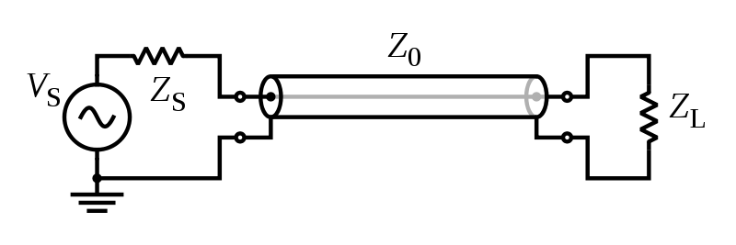

The characteristic impedance or surge impedance (usually written $Z_{0}$) of a uniform transmission line is the radio of the amplitudes of voltage and current of a single wave propagating along the line; that is, a wave travelling in one direction in the absence of reflections in the other direction. Alternatively, and equivalently, it can be defined as the input impedance of a transmission line when its length is infinite. Characteristic impedance is determined by the geometry and materials of the transmission line and, for a uniform line, is not dependent on its length. The SI unit of characteristic impedance is the ohm.

The characteristic impedance of a lossless transmission line is purely real, with no reactive component. Energy supplied by a source at one end of such a line is transmitted through the line without being dissipated in the line itself. A transmission line of finite length (lossless or lossy) that is terminated at one end with an impedance equal to the characteristic impedance appears to the source like an infinitely long transmission line, and produces no reflections.

|  |
| --- |
| **Dipole Design** |
| **Design Specification:**   1. **Frequency (f) :** 750 MHz 2. **Length of Wire (l) :** 0.5λ   **Calculation of Length of Monopole (l):**  Velocity factor=0.92     |  | | --- | | **λ =c/f=0.4 m**  **l=0.92*0.5* λ=0.184 m** |     Where,  c=Speed of light  L= Length of dipole  **Diameter of Wire (d):**  **d= λ/100** |

|  |
| --- |
| **Dipole Geometry**      **Parameter Setting** |

|  |
| --- |
| **Results** |
| 1. **Radiation Pattern** |
| **HBPW=80 degree Gain=2.11 dBi**    **HPBW=40 Gain=5.13 dBi** |
| 1. **Impedance Plot** |
| **Impedance=71.76+j0.1242 Ω**   1. **SWR and Return Loss** |
|  |
| **SWR=1.4353 Return loss = -14.955 dB**   1. **Gain Plot** |
|  |
| **Gain=2.11 dBi** |
| **Observations:**   |  |  |  | | --- | --- | --- | | **Sr.No** | **Parameters** | **Observed Values** | | 1 | HBPW | 80 degree | | 2 | Gain | 2.11 dBi | | 3 | SWR | 1.4353 | | 4 | Reflection coefficient | -14.955 dB | | **5** | Impedance | 71.76+j0.1242 Ω | |

**Conclusion:**

In this experiment, we used the 4nec2 software for the first time. This is a completely free windows based tool for creating, viewing, optimizing and checking 2D and 3D style antenna geometry structures; and generating, displaying and comparing near/far-field radiation patterns.

Our half-dipole antenna had a VSWR of around 1.4, which is good because ideally VSWR should be less than 1.8. Also, it had a reflection coefficient of around -15dB, which is good because ideally reflection coefficient should be below -10dB. Also, we noticed that the impedance of our antenna was purely resistive- its reactive component was zero at the operating frequency of 750MHz.